**25) variables** are of 3 different types. They are

1) Local variables

2) Instance variables

3)Static variable

**Local Variable:**

1. Local Variables means variables which are mentioned inside the method. Scope of these local variables lies within the method or blocks. Memory allocation for this Local variables starts when method starts and memory destroyed when method ends.
2. Initial values are not assigned.
3. Local variables inside the method can directly accessed.
4. Stack memory is used as stored memory for local variables.

**Instance variable:**

1. Instance variables are located inside the class outside the method. Scope lies within the class. Memory is created when object is created and memory ends when object is terminated.
2. Object is created when instance variables need to access in different areas.
3. Heap memory is used for memory storage.
4. Variables need to initialize.

**Static Variables:**

1. Static variables are located outside the method with static modifier. Scope of variables to access within the class.
2. Memory allocated when .class files are loaded and memory destroyed when .class files are unloaded.
3. Non Heap Memory is used for memory storage.

**23 answer**

Data types represent type of variables and decide memory size and range.

Data types are of 8 types. They are:

|  |  |
| --- | --- |
| **Data types** | **Size** |
| Byte | 1 byte |
| Short | 2 bytes |
| Int | 4 bytes |
| long | 8 bytes |
| Float | 4 bytes |
| double | 8 bytes |
| char | Single Space |
| Boolean | True or False |

**16 Answer:**

Packages in java is to combine group of classes, interfaces and sub packages.Predefined packages are present in java. Like java. Lang, java.io, java. util etc. to perform basic operations.

**18 ANSWER:**

Main method will resemble the logic of a program.

**30ANSWER:**

Variables can create inside the method and those methods are called Local variables.

Program:

Class Test

{

public Static void main (Strings [] args)

{

int a=10;

int b=12;

System.out.println(a+b);

}

}

**27 ANSWER: 60 answer**

Creating method with void :-

Class Test

{

void m1()

{

System.out.println(“M1 Method”);

}

public static void main (String [] args)

{

Test t=new Testt ();

t.m1();

}}

output:

M1 Method.

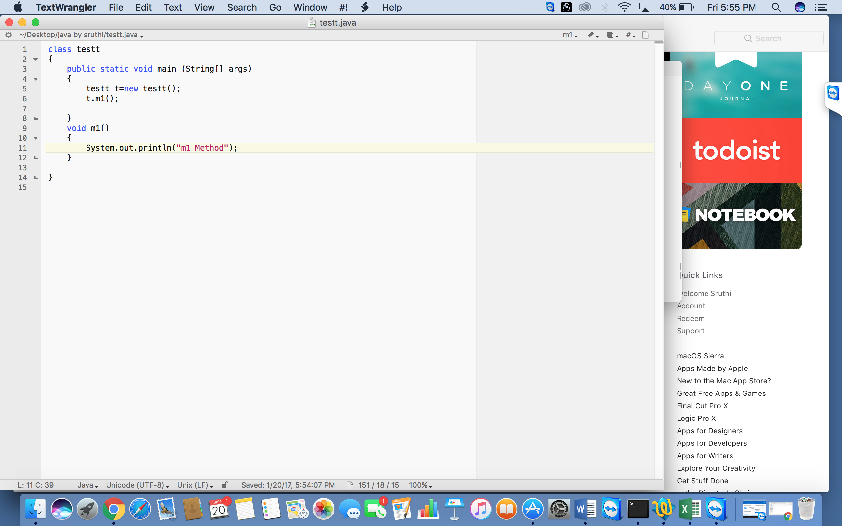

**33 ANSWER:**

Creating RETURN DATA TYPE WITH INT, STRING, DOUBLE, FLOAT

Program:

Class T

creating method with return data type, we can return int/string/double/float/date etc

program:

Class Test

{

int a=10;

string s =

double d=10.4;

float =10.0;

void m1()

[

System.out.println (“a“);

System.out.println(“

35 ANSWER:

method that will return hard coded value

class Tesst

{

int a=10;

void m1()

{

System.out.println("m1 method");

}

public static void main(Strings[] args)

{

Tesst t =new tesst();

t.m1('a');

}

37,39,42,45,47,52,62,64

**50 ANSWER: 58 ANSWER**

Creating Static method:

Class Test

{

Static int a=10;

Static int b=15;

Public static void main(string[] args)

{

Test t = new Test ()

System.out.println(t.a);

System.out.println(t.b);

}

}

**60 ANSWER:**

class Test

{

void m1()

{

System.out.println(“m1 method”);

}

}

**66Answer:/68/70**

calling method with return and parameter:

Class Test

{

int a=10;

int b=20;

static int c=30;

static d=40;

void m1()

{

System.out.println(a);

System.out.println(b);

System.out.println(Test.c);

System.out.println(Test.d);

}

static void m2()

{

Test t=new Test ();

System.out.println(t.a);

System.out.println(t.b);

System.out.println(Test.c);

System.out.println(Test.d);

}

public static void main(strings[] args)

{

Test t=new Test ();

t.m1();

Test.m2()

}

}

output:

10

20

30

40

10

20

30

40

**72 ques---74 answer**

dxasdsde

37)

class tess

{

  void sum (int a,int b)

  {

    System.out.println(a+b);

  }

  void sum( int a,int b,int cs

  {

    System.out.println (a+b+c);

  }

  public static void main (String[ ]args)

{

  tess n=new tess();

  n.sum (10,10,10);

  n.sum (20,20);

  }

}